**MULTIPLE LINEAR REGRESSION**

**MULTIPLE FEATURES**

**Understanding Multiple Linear Regression**

* **In contrast to univariate regression, which uses a single feature, multiple linear regression utilizes several features (e.g., size, number of bedrooms, number of floors, and age of a house) to predict outcomes like housing prices.**

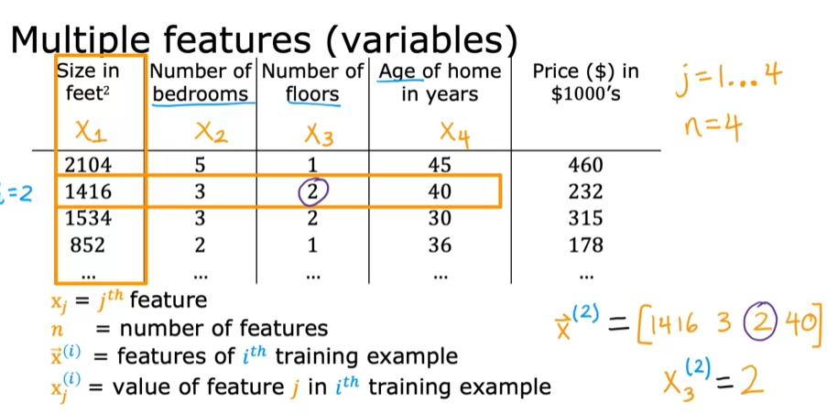

* **The model is expressed as (f(w, b, X) = w1X1 + w2X2 + w3X3 + w4X4 + b), where ( w ) represents weights for each feature and ( b ) is the bias.**

**In general, for n features:**

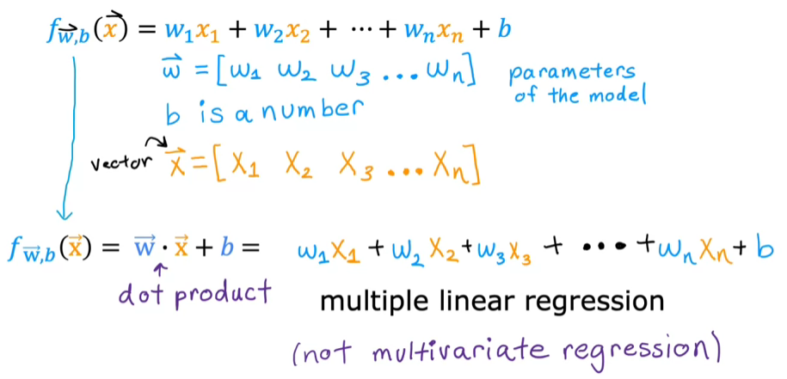

**Vectorization**

* **Vectorization allows you to write shorter and more efficient code, making it easier to read and maintain.**
* **It leverages modern numerical linear algebra libraries, such as NumPy, and can utilize GPU hardware for faster execution.**

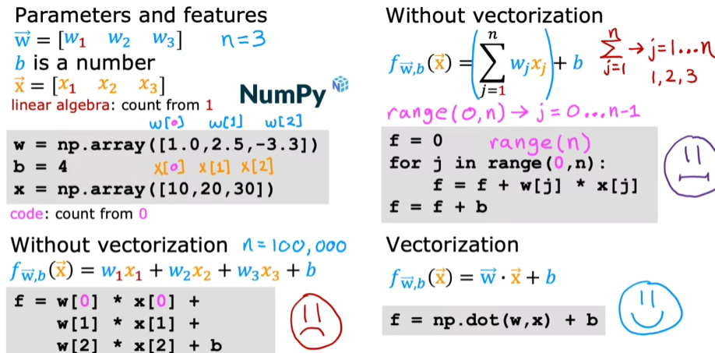

* **The vectorized implementation can be expressed in a single line of code, significantly reducing complexity.**
* **f = np. dot(w, x) + b**
* **It runs much faster due to its ability to utilize parallel hardware, making it ideal for large-scale computations. Vectorization allows operations to be performed on entire arrays or vectors simultaneously, rather than one element at a time, significantly speeding up computations. In contrast to traditional for loops that process elements sequentially, vectorized implementations leverage parallel processing capabilities of computer hardware.**

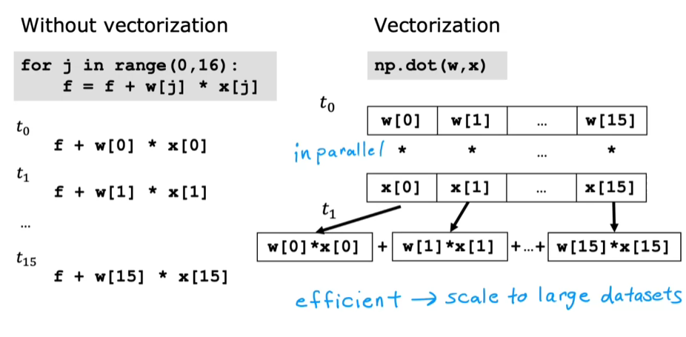

* **In multiple linear regression, vectorization allows for simultaneous updates of multiple parameters, enhancing performance.**
* **For example, updating weights can be done in one step using vectorized operations, rather than iterating through each weight individually.**

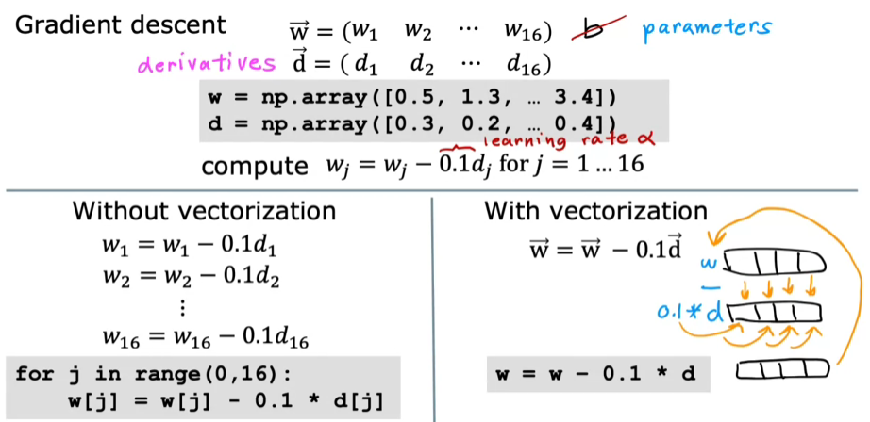

**Gradient Descent For Multiple Linear Regression**

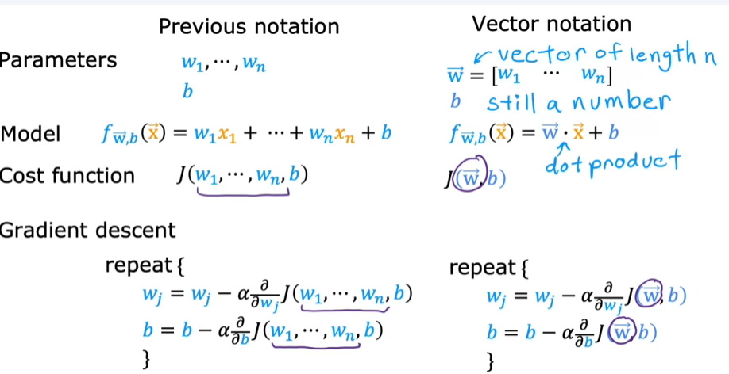

* **For multiple features, the update rules for ( w ) and ( b ) are similar to those in univariate regression, but now involve vectors.**

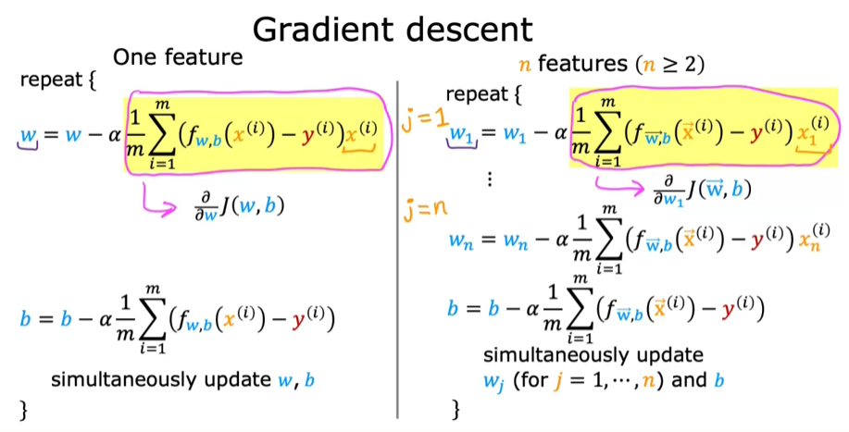

**Alternative Method: Normal Equation**

* **The normal equation is an alternative method for finding ( w ) and ( b ) without iterative updates, but it is less general and slower for large feature sets.**
* **While gradient descent is preferred for most learning algorithms, the normal equation may be used in some machine learning libraries.**

